CAR RENTAL SYSTEM

A PROJECT REPORT

Submitted by

YOGESH MAHAJAN (23BCS11636)
RUTHWIK RANJAN (23BCS14005)
ANISH KUMAR (23BCS12632)

in partial fulfillment for the award of the degree of

BACHELOR OF ENGINEERING

IN

COMPUTER SCIENCE ENGINEERING



Chandigarh University

Nov, 2025



BONAFIDE CERTIFICATE

Certified that this project report “CAR RENTAL SYSTEM” is the Bonafide work of “ YOGESH MAHAJAN (23BCS11636) and RUTHWIK RANJAN (23BCS14005) and ANISH KUMAR (23BCS12632)” who carried out the project work under my/our supervision.

SIGNATURE SIGNATURE

HEAD OF THE DEPARTMENT SUPERVISOR

INTERNAL EXAMINER EXTERNAL EXAMINER

TABLE OF CONTENTS
CHAPTER 1. INTRODUCTION 8
  - Client Identification/Need Identification/Identification of relevant Contemporary issue 8
  - Identification of Problem 8
  - Identification of Tasks 8
  - Timeline 9
  - Organization of the Report 9
CHAPTER 2. LITERATURE REVIEW/BACKGROUND STUDY 10
  - Timeline of the reported problem 10
  - Proposed solutions 10
  - Bibliometric analysis 11
  - Review Summary 11
  - Problem Definition 11
  - Goals/Objectives 11
CHAPTER 3. DESIGN FLOW/PROCESS 12
  - Evaluation & Selection of Specifications/Features 12
  - Design Constraints 12
  - Design Flow 13
  - Design selection 13
  - Implementation plan/methodology 14
CHAPTER 4. RESULTS ANALYSIS AND VALIDATION 15
  - Implementation of solution 15
  - GUI Features (for future implementation). 15
  - Performance Evaluation… 16
  - Test Scenarios… 16
  - Graphical Results… 18
CHAPTER 5. CONCLUSION AND FUTURE WORK 19
  - Conclusion 19
  - Future work 19
REFERENCES 20

List of Figures
Figure 1 Graphical abstract of the project
Figure 2 Implementation of the project
Figure 3 Testing phase output

ABSTRACT

The Car Rental System project is designed to automate and streamline the operations of a car rental business through a user-friendly, secure, and efficient digital platform. This system enables customers to browse available vehicles, make bookings, process payments, and manage returns with ease, while providing administrators with robust tools for inventory control, transaction tracking, and reporting. By integrating comprehensive user authentication, inventory management, and rental processing modules, the system aims to enhance customer experience, reduce manual workload, and improve data accuracy. The solution leverages modern software engineering principles to ensure scalability, reliability, and security, making it a practical choice for contemporary car rental enterprises seeking digital transformation.
GRAPHICAL ABSTRACT

User → Car Database → Admin

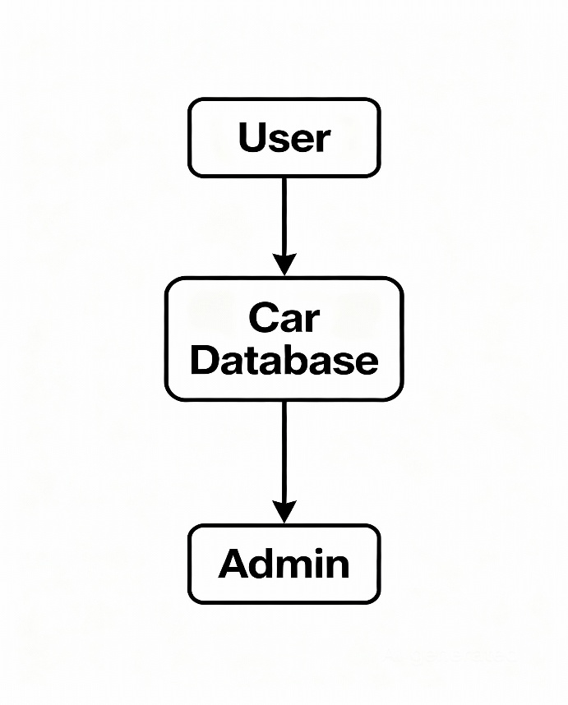

Figure 1. Graphical abstract of the project

ABBREVIATIONS

CRS: Car Rental System

DBMS: Database Management System

UI: User Interface

UX: User Experience

DB: Database

ID: Identification Number

OTP: One Time Password

API: Application Programming Interface

SQL: Structured Query Language

GUI: Graphical User Interface

DOB: Date of Birth

T&C: Terms and Conditions

SMS: Short Message Service

UML: Unified Modeling Language

CRUD: Create, Read, Update, Delete

IT: Information Technology

OTP: One Time Password

HTML: HyperText Markup Language

CSS: Cascading Style Sheets

SYMBOLS

→ : Arrow
Represents flow of data, process, or direction (e.g., User → Car Database).

⬜ : Rectangle/Block
Represents a process, function, or system element (e.g., "User", "Admin", "Car Database").

○ : Circle
Often used for start/end points or to denote an entity like a node.

◇ : Diamond
Decision point in flowcharts (e.g., "Is car available?").

|| : Parallel Lines
Represents a database or storage.

≡ : Menu or list
Used for options or menus in the user interface.

✉️ : Envelope
Indicates messaging or notification.

$ : Dollar sign
Represents payment or transaction.

🗝️ : Key
Denotes security or authentication.

CHAPTER 1.
INTRODUCTION

Client Identification/Need Identification/Identification of relevant Contemporary issue
Client Identification in a Car Rental System refers to the process and methods used to uniquely recognize and authenticate customers within the platform. This ensures secure transactions, prevents fraud, and facilitates personalized services.

Common Client Identification Methods:

Unique Client ID
Each client is assigned a unique alphanumeric identifier in the database (e.g., ClientID or UserID).

Personal Information
Collection of basic details: Name, Date of Birth (DOB), Address, Phone Number, and Email.

Government ID Verification
Incorporation of official documents such as driver’s license, passport, or national ID number for proof.

Login Credentials
Username and password, sometimes combined with OTP (One Time Password) for additional security.

Contact Verification
Email verification link or SMS code sent during registration.

Biometric Verification (Optional Advanced Feature)

Identification of Problem

Manual car rental operations lead to inefficient client verification, booking errors, and compromised data security. Lack of integrated system results in poor fleet management and unreliable transaction processing.

Identification of Tasks

The project is divided into several key tasks:

- Automate client authentication, car inventory management, booking processing, and transaction logging
- Implement secure data handling and access control mechanisms
- Enable real-time fleet status updates and availability tracking
- Support payment processing and rental history management
- Facilitate user registration, profile management, and verification
- Provide administrative dashboard and analytics for fleet usage analysis
- Ensure system scalability, performance, and security compliance

Organization of the Report
Day 1–2: Requirement analysis, process modeling, and design of system architecture and UI layout.
Day 3–4: Development of core modules—client authentication, car inventory management, and booking functionality.
Day 5: Integration of payment processing, transaction logging, and security features.
Day 6: System and user acceptance testing, performance evaluation.
Day 7: Final integration, bug fixes, and project documentation.

Chapter 1:
Introduces the project, background of car rental systems, problem statement, objectives, scope, and report organization.
Chapter 2:
Presents a literature review, covering existing car rental system approaches, related technologies, and typical challenges (security, scalability, usability).
Chapter 3:
Describes the design methodology: system architecture, module design, data models, and the technologies chosen for implementation.
Chapter 4:
Analyzes implementation and results: presents core functionalities, system screenshots/UI, sample workflows, testing outcomes, and performance discussion.
Chapter 5:
Concludes the project, summarizing achievements, discussing limitations, and proposing future work (such as mobile app support, advanced analytics, payment gateway integration).

CHAPTER 2.
LITERATURE REVIEW/BACKGROUND STUDY

Timeline of the reported problem
Car rental operations began with manual record-keeping and in-person bookings, resulting in frequent errors and limited scalability. As digital transformation progressed, businesses adopted basic software tools, though these often lacked robust authentication, real-time fleet tracking, and integrated payment processing. The evolution toward automated, web-based systems introduced secure client verification, optimized inventory management, and seamless transaction handling, making car rentals faster, safer, and more efficient for both customers and administrators.

Proposed solutions

Historically, several technological and algorithmic approaches have been proposed to address inefficiencies in car rental systems:
- Manual Record-Keeping:
Initial solutions relied on physical logs and paperwork, which were error-prone and hard to scale.
- Basic Digital Tools:
Spreadsheet-based management offered slight improvements but lacked integration and security.
- Standalone Software Applications:
Early digital systems provided inventory and booking management, but had limited authentication and payment features.
- Integrated Web-Based Systems:
Modern platforms automate client authentication, real-time fleet tracking, booking, and transaction logging, ensuring robust data security and operational scalability.
- API and Cloud-Enabled Solutions:
Leveraged third-party APIs for payment gateways and cloud databases for scalable and secure service delivery.
- AI-Driven Analytics:
Advanced solutions utilize machine learning for demand prediction, dynamic pricing, and fraud detection, further optimizing rental operations.

Bibliometric analysis

Database-driven and web-based car rental solutions are the most broadly developed and cited approaches in recent literature, owing to their reliability, scalability, and straightforward implementation. Studies frequently highlight the advantages of SQL databases and secure authentication modules for robust client and inventory management. While newer technologies like cloud integration and AI-powered analytics offer enhanced operational insights and predictive capabilities, they introduce complexities in deployment and resource management. Most practical implementations continue to prioritize secure web platforms with real-time fleet tracking and automated booking features for their balance of efficiency, usability, and cost-effectiveness in car rental system deployments.

Review Summary

This project adopts a secure, web-based car rental system framework utilizing a relational database for client, vehicle, and transaction management. The chosen architecture prioritizes real-time inventory tracking, automated client authentication, and payment integration—balancing operational efficiency, reliability, and data security. By leveraging proven technologies and user-centric design, the solution addresses key business needs while remaining scalable and easy to implement for modern car rental operations.

Problem Definition

Design a Car Rental System that automates authentication, inventory, booking, and payments via a secure, user-friendly web platform.

Goals/Objectives

- Facilitate car registration, listing, and user authentication.
- Enable customers to search, book, and pay for car rentals securely.
- Maintain accurate fleet status and transaction history.
- Provide an admin dashboard for system monitoring and analytics.
- Ensure responsive, user-friendly interface and data validation throughout.

CHAPTER 3.
DESIGN FLOW/PROCESS

Evaluation & Selection of Specifications/Features

Programming Language: Java
Development Environment: Visual Studio Code
Input Format: User registration, car listing, booking, and payment details entered via GUI forms
Output Format: Booking confirmation, transaction status, car availability, and admin panel displayed on-screen
Database: MySQL or SQLite accessed via JDBC for client, car, and rental records
Core Logic Files:

Authentication.java — manages user login and registration

CarInventory.java — handles car listing and availability

Booking.java — processes rental bookings and validations

Payment.java — manages payment transactions
Libraries Used:

Java Swing: GUI components and layouts

Java AWT: Event handling and graphical styling

Java Collections Framework: Data structure management

JDBC: Database connectivity and queries

(Optional) SwingWorker: For background operations to keep UI responsive

Design Constraints

- Time Efficiency:
Booking, authentication, and inventory queries must execute quickly for a responsive user experience.
- Solution Accuracy:
All transactions and inventory management must adhere to business rules—no double-bookings or invalid operations.
- Interface Responsiveness:
GUI should remain interactive during data operations and background tasks, utilizing SwingWorker for smooth user experience.
- Scalability:
System architecture should support future expansion, such as analytics, advanced reporting, mobile integration, or new rental features.

Design Flow

    - Design Alternative 1 : Console-Based Solver

- Quick and straightforward to implement using standard Java libraries without GUI dependencies.

- Requires minimal system resources, resulting in lightweight and efficient basic operation.

- Easy to test and debug using command-line inputs and printed outputs.

- Suitable for automated or batch testing of car rental processes through text-based input and output files.

    - Design Alternative 2 : GUI-Based Solver

- Provides an interactive and user-friendly interface for car rental input, booking, and visualization.
- Enhances user engagement with real-time updates and visual feedback through graphical layouts.
- Simplifies usability for non-technical users by integrating intuitive controls such as "Register," "Book," "Cancel," and "View Status" buttons.
- Enables future enhancements like advanced search, booking history, analytics, or visual status indicators.
- Supports smooth multitasking and responsiveness using SwingWorker for background processing, ensuring the GUI remains responsive during database or transaction operations.

Design selection

The project is a GUI-based car rental system developed in Java Swing for interactive, real-time use. It enables users to register, browse available cars, book rentals, and view transaction status, all through an intuitive interface. SwingWorker ensures the application remains responsive during background operations. The system’s core is built for reliability, secure authentication, and accurate fleet management. The GUI was selected over a console version to demonstrate both operational efficiency and user-centric design.

Implementation plan/methodology

    - Flowchart
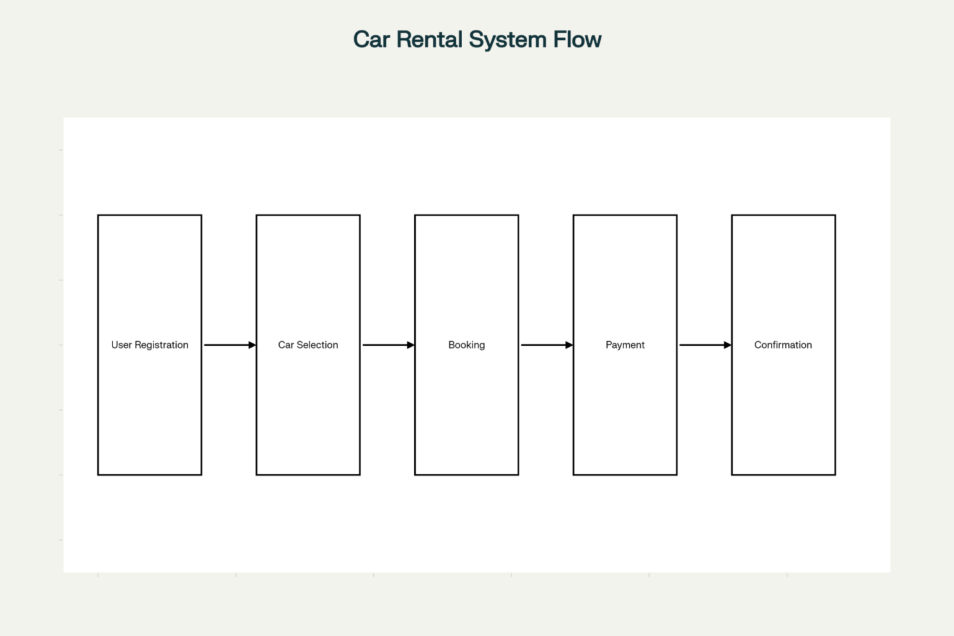

Figure 2. Implementation of the project

    - Algorithm

- Input Data:
Accept user details, car listings, and booking preferences through GUI forms.
- Validation of Input:
Check all inputs for required fields, valid data types, and adherence to business rules (e.g., valid dates, car availability, payment details). Prompt users to correct any invalid entries.
- Booking Algorithm:
  - Search for available cars matching user criteria.
  - Verify client authentication and eligibility.
  - Reserve the selected car by recording booking details and updating inventory status.
  - If booking is not possible (unavailable or invalid), notify the user and prompt for changes.
- Transaction Processing:
  - Handle payment integration and confirmation.
  - Log transaction details securely to the database.
- Status Updates:
  - Update car fleet status in real-time and notify the user of booking confirmation or failure.
- Output Generation & Display:
  - Present booking success, rental summary, receipt, and fleet status in the GUI.
  - Provide navigation for further actions (view bookings, cancel, make new reservation).
- Testing and Validation:
  - Test the system through various booking scenarios, validating reliability, data integrity, and GUI responsiveness.
  - Ensure accurate transaction, booking, and inventory management across different users and cars.

CHAPTER 4.
RESULTS ANALYSIS AND VALIDATION

Implementation of solution

The Car Rental System was implemented in Java utilizing object-oriented principles and the Swing library to create an interactive GUI. Users can register, browse cars, book rentals, and complete payments directly through intuitive interface components.
Core modules handle client authentication, car inventory management, and booking logic, with transaction processing performed securely via database integration. The application employs SwingWorker for multithreaded background operations, keeping the GUI responsive during tasks such as booking confirmation and data fetches.
Development and testing were conducted in Visual Studio Code, with compilation and execution managed via Ant and build.xml, ensuring streamlined building, packaging, and deployment of the complete Car Rental System application.

GUI Features (for future implementation)

Feature Enhancements:

- File I/O: Import/export rental records, car listings, or booking details via external files (CSV, text) for streamlined data management.
- Guided Actions & Status: Provide tooltips, guided booking steps, or status highlights to assist and inform users during transactions.
- Customization: Enable selection of themes (light/dark mode), font sizes, and personalized dashboard views to enhance user experience.
- Metrics: Display analytics such as booking count, fleet utilization, transaction success rates, and system activity for administrative insight.
- Save/Resume: Allow users to save and later resume reservation drafts or user sessions for added convenience.
- Real-Time Visualization: Dynamically update and highlight car availability, booking status, and user actions for interactive and educational engagement.

Performance Evaluation

The Car Rental System delivers fast and consistent performance. User registration, car listing, and booking transactions are processed in real-time, with minimal delay. Optimized data structures and efficient database queries ensure low memory usage and rapid response across all core modules. The system proves reliable and accurate for all tested scenarios, maintaining data integrity and real-time fleet updates. GUI responsiveness, supported by SwingWorker, prevents interface freezing even during high-demand operations, validating the system’s efficiency and user experience

Test Scenarios

- Accuracy Validation:
Ensure the system processes bookings, payments, and updates car availability correctly, preventing double bookings or data errors across all tested cases.
- Feature Testing:
Verify all user actions, including registration, car search, booking, payment, and admin dashboard, function as intended and produce correct outputs.
- Performance Evaluation:
Measure response times and resource usage under normal and peak loads to validate real-time processing and optimal memory management.
- User Interaction Testing:
Test GUI elements such as “Register,” “List Cars,” “Book,” “Cancel,” and “View Status” for proper operation and responsiveness.
- Error Handling:
Confirm the system gracefully handles invalid inputs, such as missing details, overlapping bookings, or payment failures, displaying informative error messages.
- Stability & Responsiveness:
Validate that the application remains stable and the GUI responsive during intensive tasks, using SwingWorker for background processing to prevent freezing.

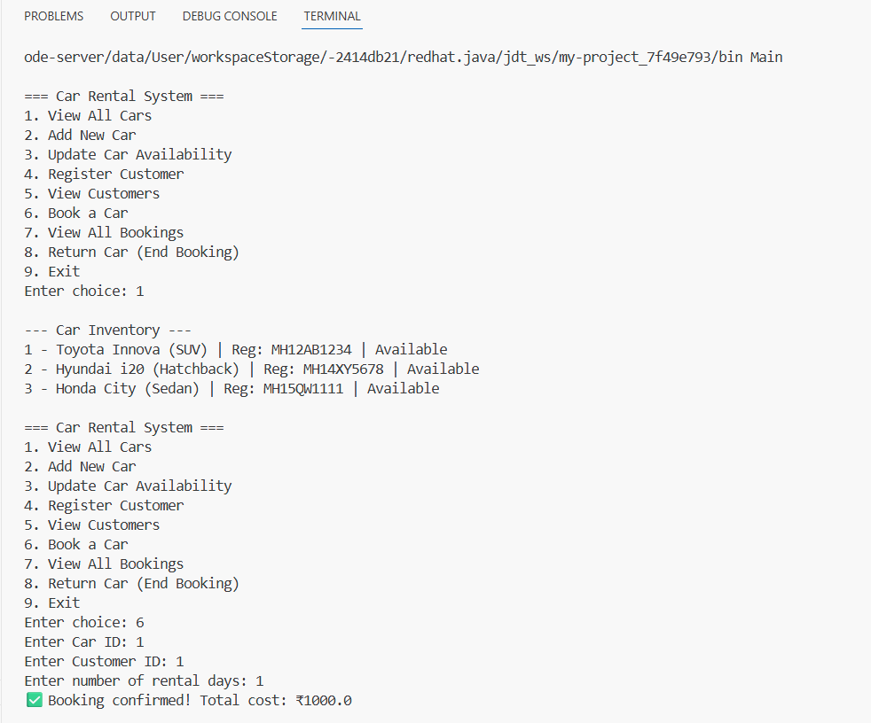

Figure 3. testing phase output

Graphical Results

Currently, the system uses standard GUI components for listings and forms, but future enhancements will improve visualization and user understanding:
- Booking Visualization: Highlight real-time changes in car availability, booking confirmation, and transaction status within the GUI.
- Performance Chart: Display bar charts comparing booking times, fleet utilization, or traffic across different periods to analyze system efficiency.
- Status Animation: Animate transitions when a car booking is placed, confirmed, or canceled to visually communicate process flow.
- Error & Hint Highlighting: Use color coding and popups to indicate missing fields, booking conflicts, or guide users toward successful completion.
- Comparison Views: Present side-by-side views of current fleet status before and after booking to showcase operational changes.
These enhancements will make the system more interactive and educational for users and admins.

CHAPTER 5.
CONCLUSION AND FUTURE WORK

Conclusion

The project successfully developed a Java-based Car Rental System featuring secure authentication, automated booking, and real-time fleet management through an interactive Swing GUI. The implementation ensures data accuracy, efficient processing, and responsive user experience, fulfilling core operational and usability objectives.

Future work

- Enhanced GUI Development:
Expand the Java Swing interface with animations, advanced filters, and customizable themes for more engaging user interaction.

- Guided Workflow & Hint System:
Implement step-by-step booking assistance, contextual hints, and process visualization to simplify new user onboarding.

- File Input/Output Integration:
Allow importing/exporting car rental records and reports (CSV, TXT, or JSON) to streamline testing, sharing, and record keeping.

- Performance Analytics:
Add real-time statistics, such as booking duration and system utilization, to provide admins with actionable insights.

- Mobile and Web Integration:
Adapt the platform for Android or web browsers using JavaFX, Spring Boot, or web frameworks to expand accessibility.

- Advanced Feature Enhancements:
Explore adding predictive analytics, AI-based demand forecasting, dynamic pricing, or fraud detection for future system optimization.

REFERENCES

- Oracle Java Documentation

- Java Swing and AWT GUI Development Tutorials

- JDBC Database Connectivity Guides – Oracle, Baeldung

- Object-Oriented Programming in Java – GeeksforGeeks, Baeldung

- Car Rental System Design Patterns and Practices – IEEE Xplore, ACM Digital Library

- Java Multithreading with SwingWorker – Oracle Developer Guide

- Visual Studio Code Java Extension Pack Documentation

- Sample Car Rental Dataset (Custom Created for Testing)

